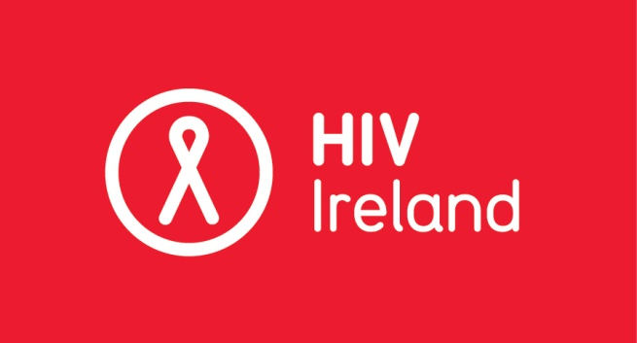

“National Survey on HIV in Ireland”

About HIV Ireland and our work
HIV Ireland (HIVI) is a registered charity operating at local, National and European level. The principal aim of the organisation is to improve, through a range of support services, conditions for people living with HIV and Hepatitis, their families and their caregivers while further promoting sexual health in the general population.
Our mission and vision is to contribute towards a significant reduction in the incidence and prevalence of HIV in Ireland and towards the realisation of an AIDS-free generation by advocating for individuals living with HIV, preventing new HIV infections and combating HIV-related stigma and discrimination.
Since 1987 HIV Ireland (formerly Dublin AIDS Alliance) has been pioneering services in sexual health education and promotion, and has consistently engaged in lobbying and campaigning in the promotion of human rights. Our approach broadly reflects a harm minimisation model which emphasises practical rather than idealised goals. For more information visit www.hivireland.ie .
Context
HIVI has secured funding from Janssen to undertake a National Survey on HIV in Ireland covering two broad areas:
- The individual experiences of people living with HIV in Ireland of stigma and discrimination, especially within the context of:
- Personal relationships (friends, family and partners)
- Health
- Employment & Education
- Welfare Services
- The level of awareness, knowledge and understanding of HIV amongst the general public, with a particular emphasis on the general public’s attitude towards HIV and people living with HIV.
With newly diagnosed HIV figures increasing within Ireland (www.hpsc.ie), HIV Ireland believes it is imperative we gain greater knowledge and understanding of how HIV is currently impacting on the lives of people living with HIV and how HIV is understood and viewed by the general public.

In conducting this particular survey, for comparative purposes, HIV Ireland would expect consideration to be given to previous research, e.g. the 2007 Stamp Out Stigma campaign in Ireland and the 2014 study of Public Knowledge and Attitudes of HIV in the UK.
Required Expertise
- Experience of research in the social sciences (e.g. health promotion, psychology, sociology, social policy).
- Experience of conducting quantitative research including national representative work.
- Expertise in data analysis using statistical software (e.g. SPSS).
- Ability to liaise with key stakeholders.
- Experience in producing high quality research to publication standard.
- Exceptional attention to detail and ability to adhere to budgetary and deadline requirements.
- Experience of working with vulnerable groups and an understanding of the sensitivities that can arise when doing so.

Invitation to Tender
HIV Ireland invites submissions of tenders to deliver the specific project detailed below:
METHODOLOGY | - Quantitative survey data will be gathered from samples of people living with HIV, and from the general public.  - Data will be gathered using questionnaires, which will be available in both electronic and printed formats.  - The survey will be advertised online through social media, and through appropriate organisations (e.g. hospitals and non-governmental organisations).  - Ethical approval will be obtained from a research ethics committee (HIV Ireland will work with the successful tenderer to achieve this).
BUDGET | This will be a fixed price contract for services (inclusive of V.A.T., travel, subsistence, word and data processing, printing, overhead expenses, and attendance at the launch event). Payment will be phased and linked to progress as follows:  Stage 1: 20% on awarding of tender by the steering group.  Stage 2: 30% on completion of data collection as agreed with steering group.  Stage 3: 30% on completion of data analysis as agreed with steering group.  Stage 4: 20% on final publication of report as agreed with steering group.
AIMS/ OBJECTIVES | - Identify issues affecting people living with HIV in Ireland relative to stigma and discrimination.  - Gain a better understanding of the knowledge and attitude of members of the public towards HIV and people living with HIV in Ireland.  - Use the results of this survey to educate the public on issues related to HIV in Ireland.
DELIVERABLES | The key output of this project will be a report for launch. The researcher will be expected to participate in the launch event.
STEERING GROUP | The successful researcher will be supported by a steering group consisting of HIV Ireland staff members and people working independently of HIV Ireland. The role of the steering group will be to oversee and sign off on the 4 stages of the process culminating in a launch of the completed survey in 2016 (launch date to be decided).

Tax/ VAT
Valid tax clearance certificates will be sought from the successful tender.

Tender Process:
Individuals or organisations who wish to submit a tender must submit a document of no more than 5 pages in total. The tender should include:

- A profile, CV or portfolio of the individual or organisation submitting the proposal.
- Details of how the proposed methodology will be implemented in order to meet the aims and objectives of this proposed project.
- Costing and timeline with respect to the proposed work expressed within the overall budget (inclusive of VAT if applicable) – circa €12,000.

Assessment of Tender:
Each tender received will be assessed on the basis of:

CRITERIA * | SCORE
Demonstrated knowledge and understanding of the brief | 30
Track record in relevant work | 20
Approach/methodology | 20
Value for money | 20
Time to delivery of final report from initiation of the project | 10
Total | 100
*Please note minimum 50% required in each criteria section for consideration.

To note:
- Additional information may be sought at the assessment phase.
- Before a final decision is made, a number of the most competitive tenders may be invited for further discussion on their proposals for the purpose of elaboration, clarification and/or aiding mutual understanding.
- HIV Ireland shall not be liable for any costs and/or expenses incurred in respect of the
preparation or the submission of any tender documents or associated material.
- HIV Ireland reserves the right not to award the tender to any of the candidates if it is
deemed the tenders are not of a sufficient standard.
- The tender process and subsequent work will be overseen by a Steering Group.
- The researcher will report on progress to the Steering Group at specified intervals.
- All data gathered and the subsequent report will remain in the ownership of HIV Ireland.

Lowest price tender is not a guarantee of success.
Tenders to be submitted by e-mail to niall.mulligan@hivireland.ie by
5.00pm on Monday 2nd November 2015
HIV Ireland, 70 Eccles Street, Dublin 7 Tel: 01 8733799; Fax 01 8733174 E: info@hivireland.ie; W: www.hivireland.ie.
Dublin AIDS Alliance Ltd trading as HIV Ireland is a company limited by guarantee without a share capital: No. 206162. Reg. No. 8206162 S. Charity No. CHY 10858. Directors: S. Rourke (Chairperson), J. McDonagh (Secretary), S. Kennedy (Treasurer), P. Quigley, E. Le Prince, A. O’Connor, B. Jordan, B Condon.

